Water temperature at Lower Granite Forebay, comparison of 2016, 2015 and 2005-2014 average (DART)

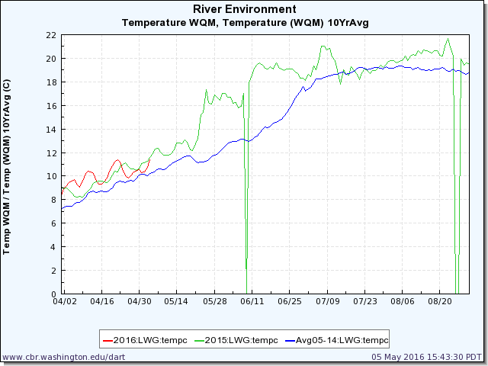

Comparison of all years from 1985-2016 when water temperatures at Lower Granite were greater than or equal to 7° C by March 16.

